Lease Management

College Name : ADHARSH VIDHYALAYA COLLEGE OF ARTS AND SCIENCE FOR WOMEN

College Code : bru5h

TEAM ID:

TEAM MEMBERS: 4

Team Leader Name: JANANI M

Email : [mathankumar100209@gmail.com](mailto:mathankumar100209@gmail.com)

Team Member : ABINAYA A

Email : abinayaalagesan2810@gmail.com

Team Member : ILAMATHI P

Email : [ilamathiperumal97@gamil.com](mailto:ilamathiperumal97@gamil.com)

Team Member : MANJUSHREE M

Email : [mercymanju27@gmail.com](mailto:mercymanju27@gmail.com)

1.INTRODUCTION

1.1 Project Overview :

Lease management is the process of efficiently handling all activities related to leased properties, asserts, or equipment. It involves recording, monitoring and controlling lease agreements to ensure compliance, cost saving, and smooth operation.

1.2 Purpose :

The main objective of the project is to enable organizations to efficiently manage properties, tenants, and lease-related activities. It reduces manual interventional, improves accuracy, and ensures better compliance and communication.

# DEVELOPMENT PHASES

## Creating Developer Account : https://naanmudhalvan.smartinternz.com



* Create Object : Property, Tenant, Lease, Payment

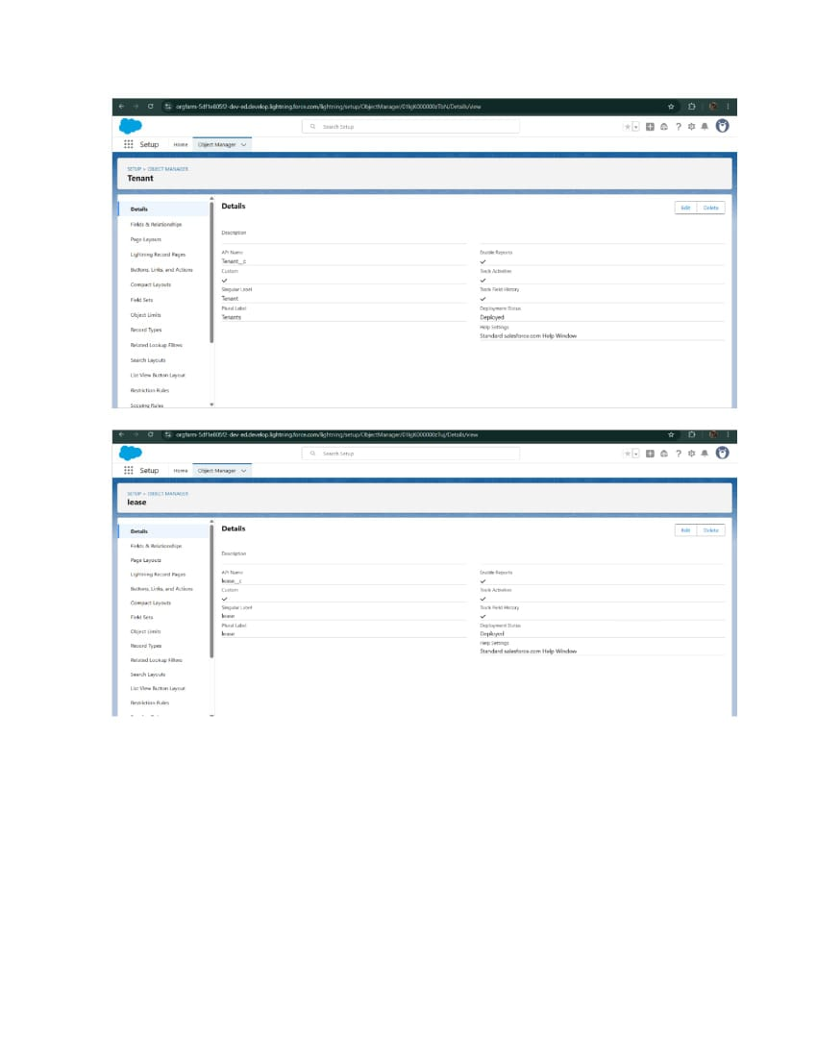

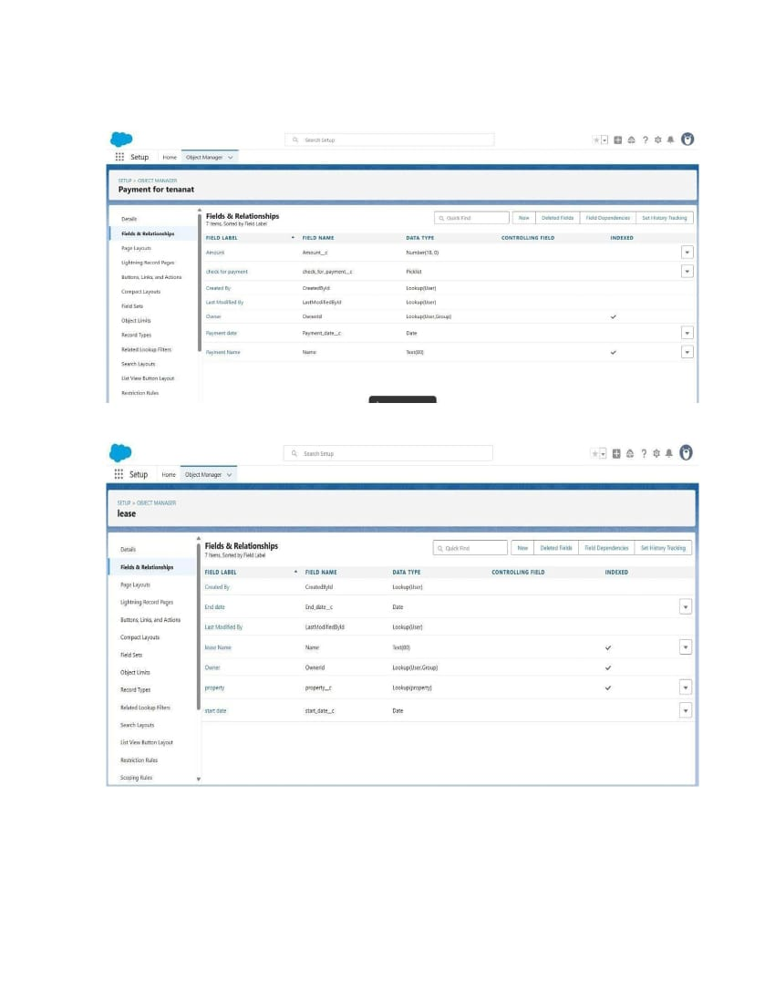

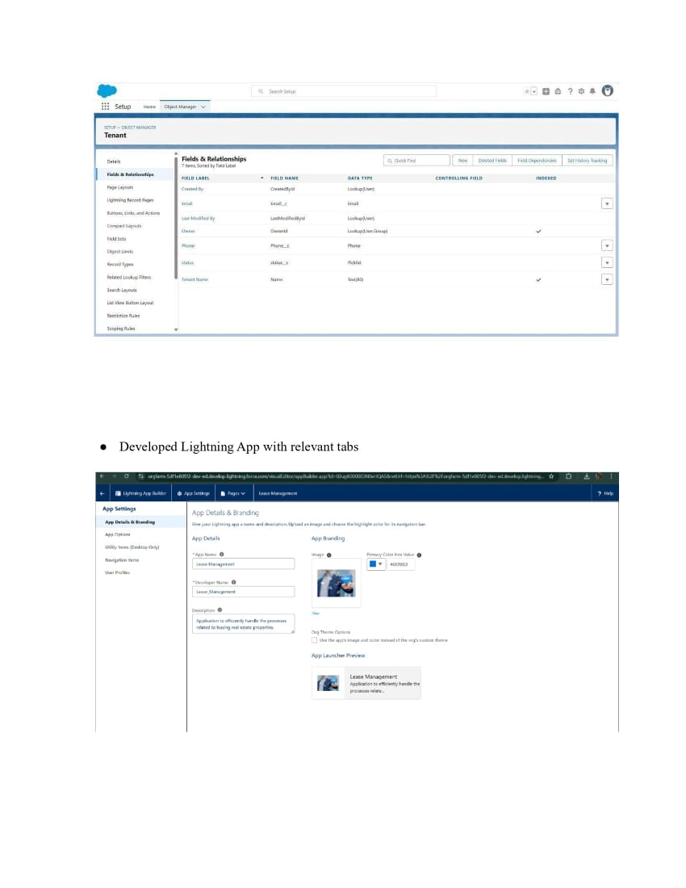

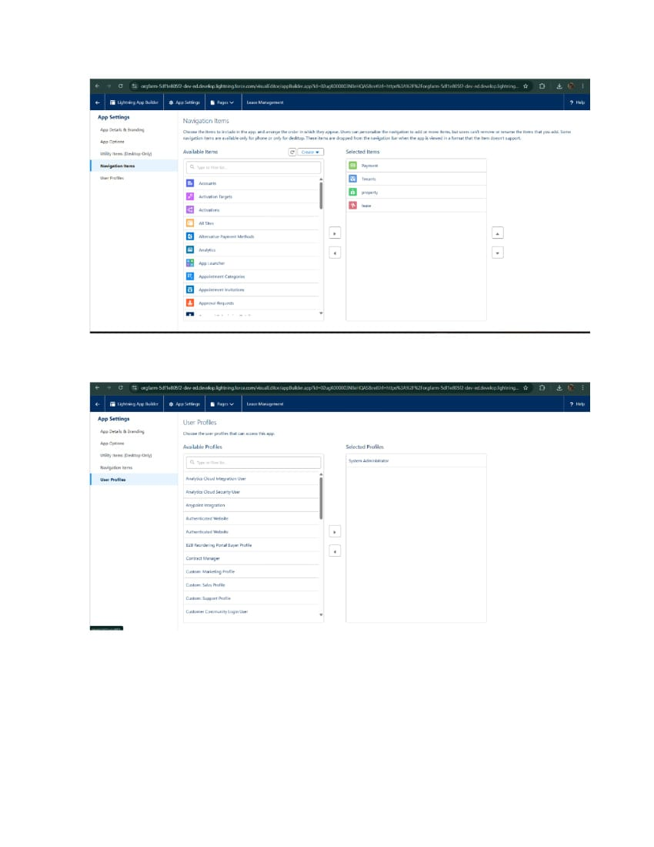

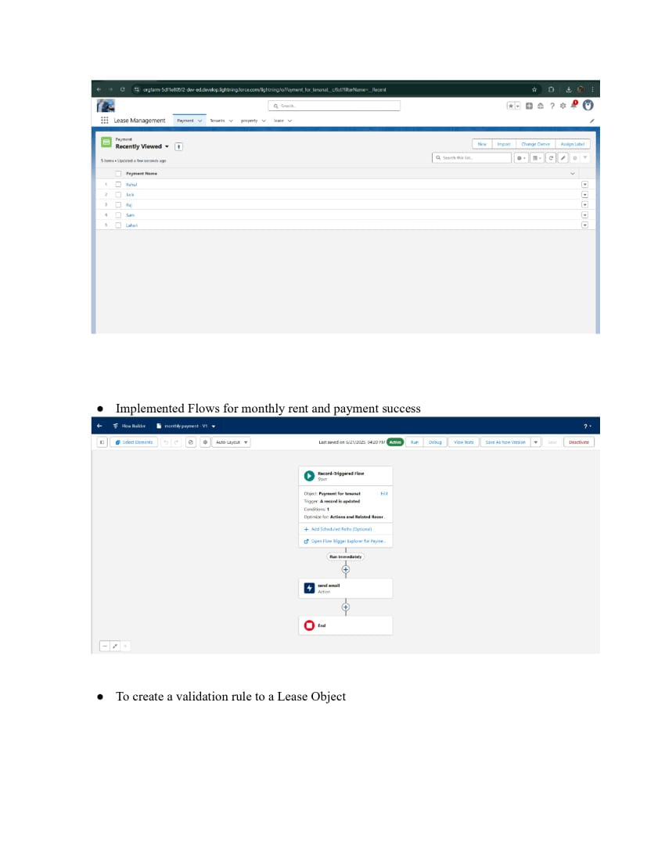

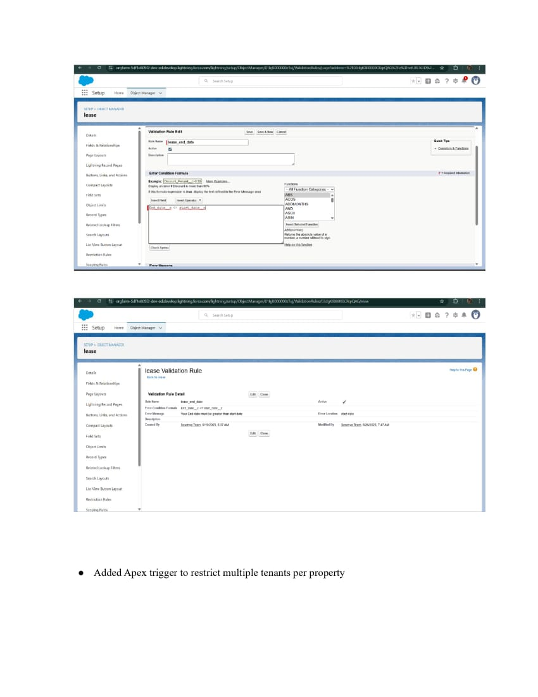

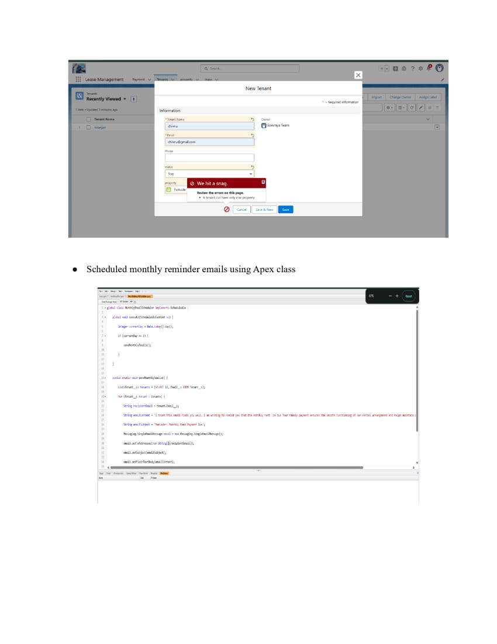

# page 10.jpg

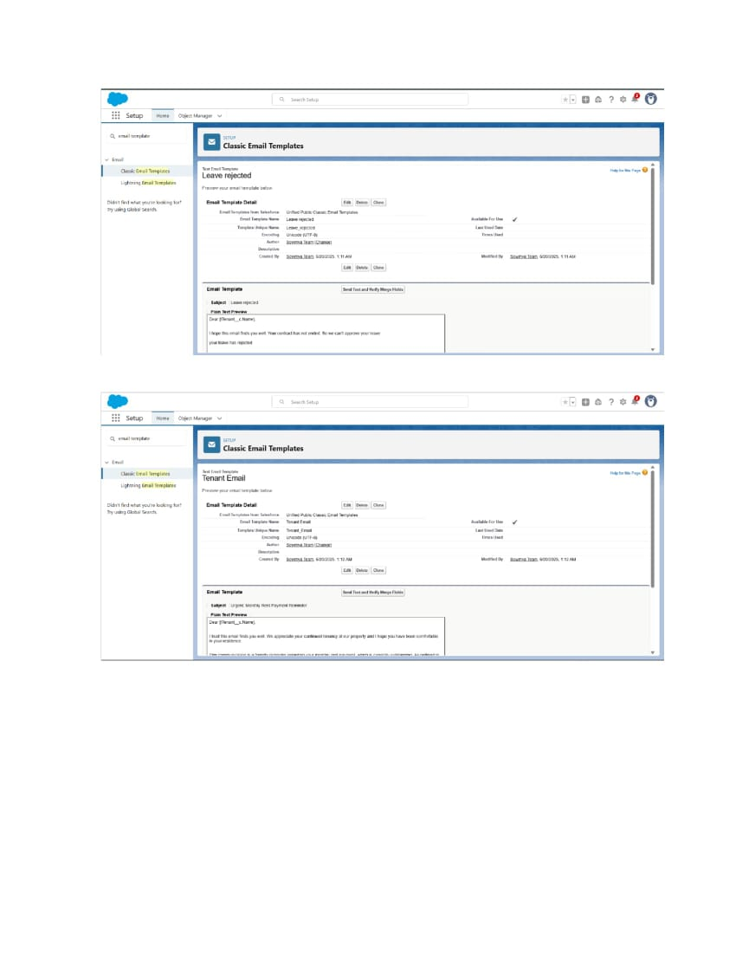

# page 12.jpg

# page 13.jpg

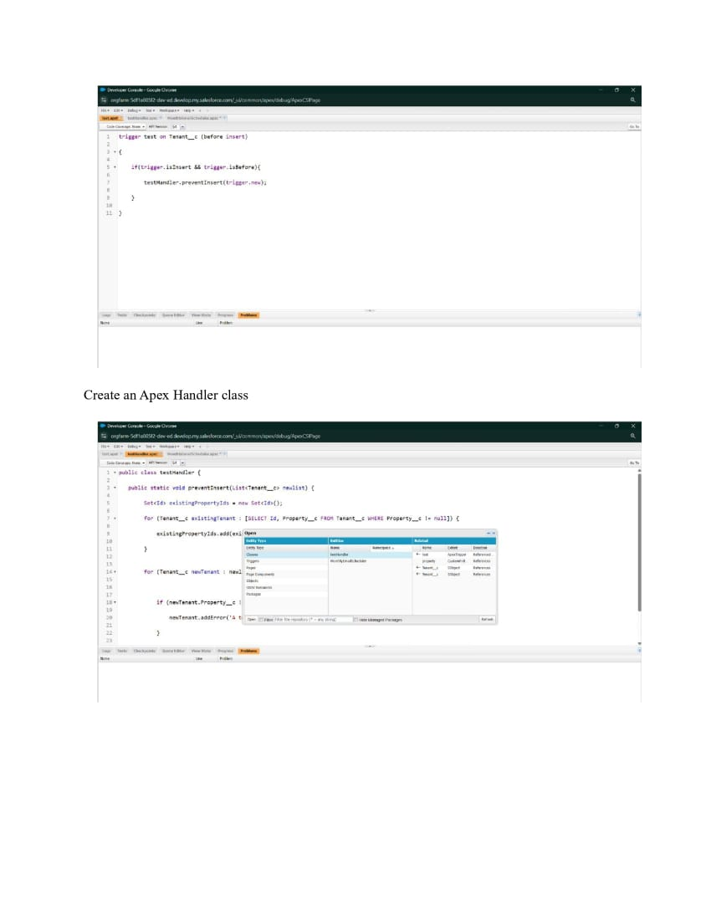

# page 15.jpg

# page 16.jpg

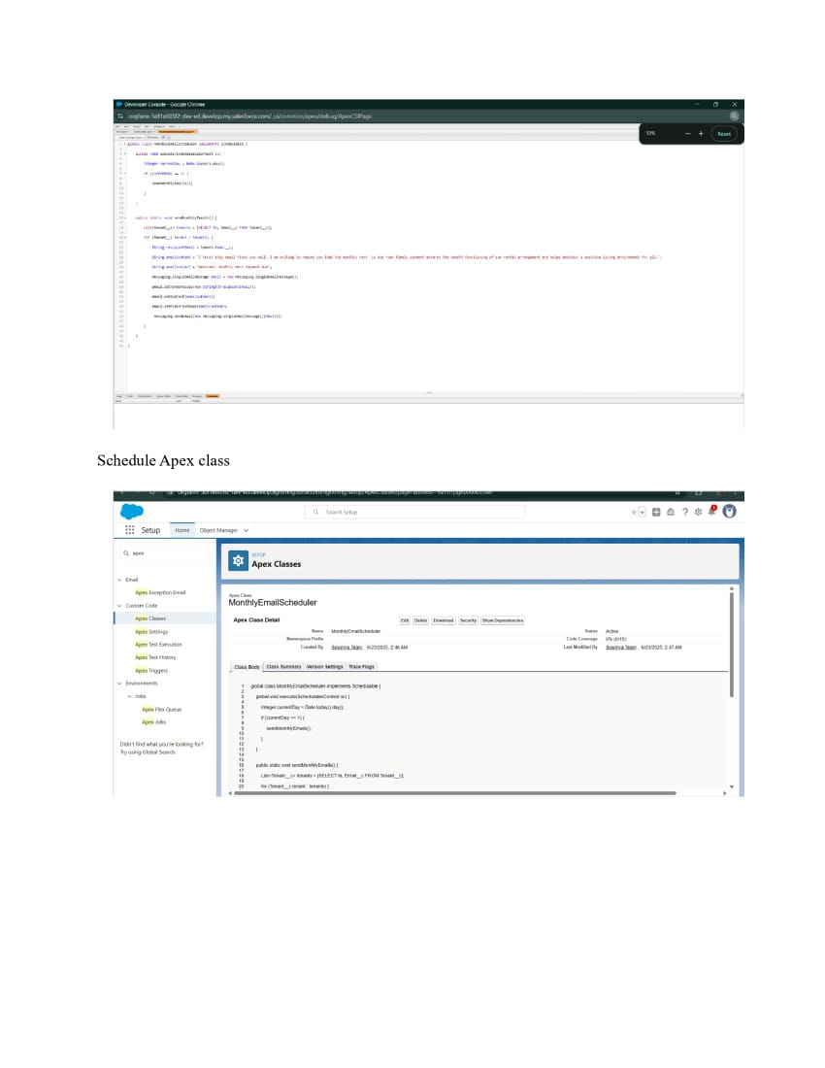

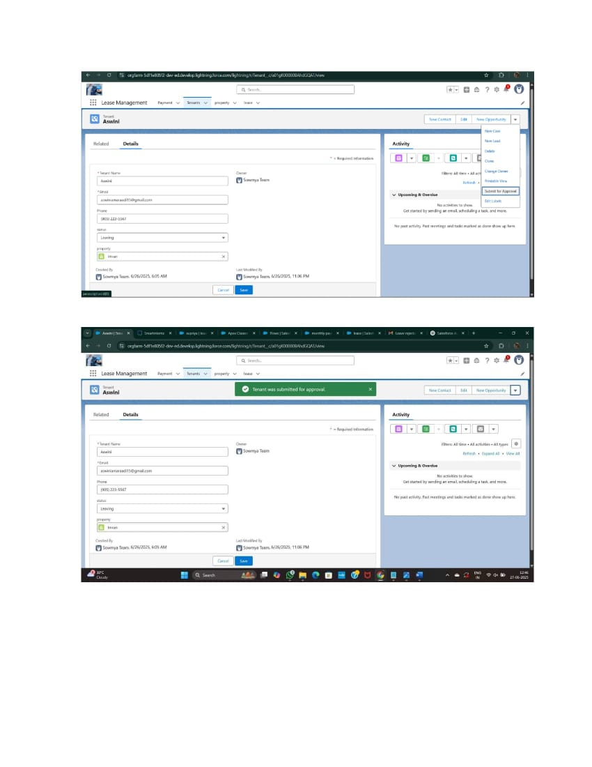

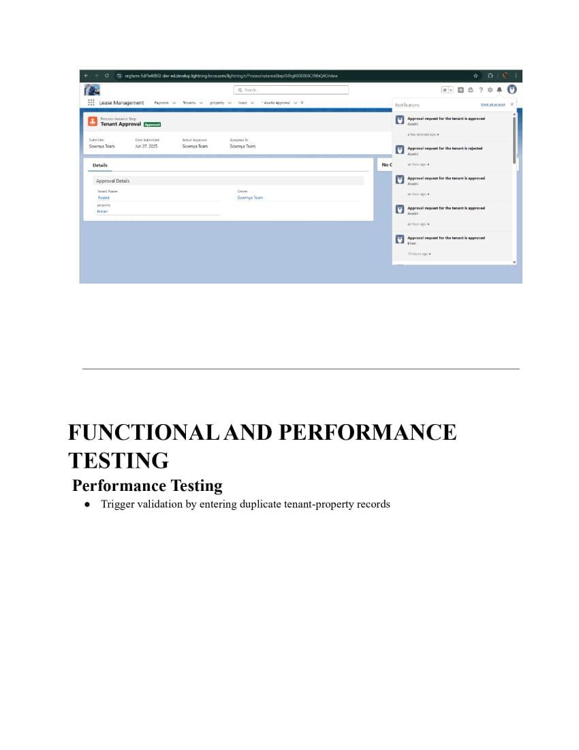

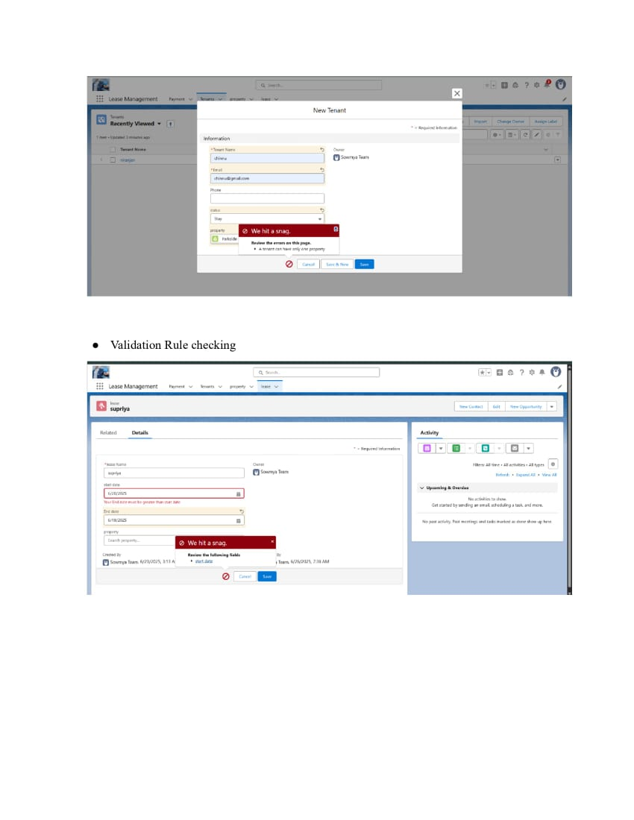

# page21.jpg

# page22.jpg

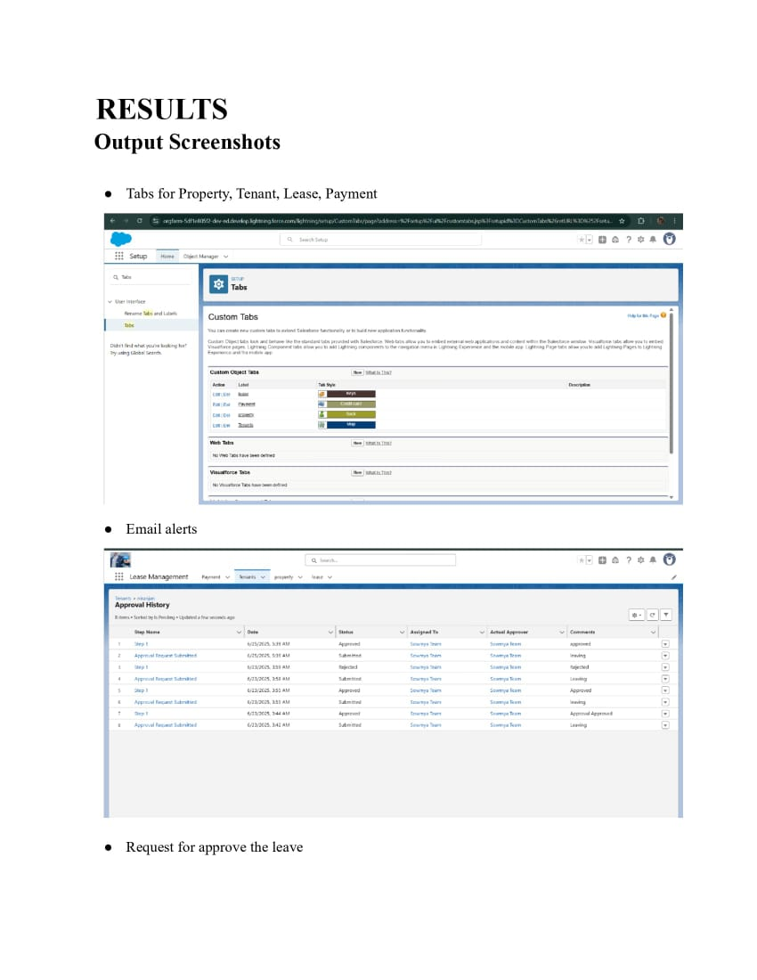

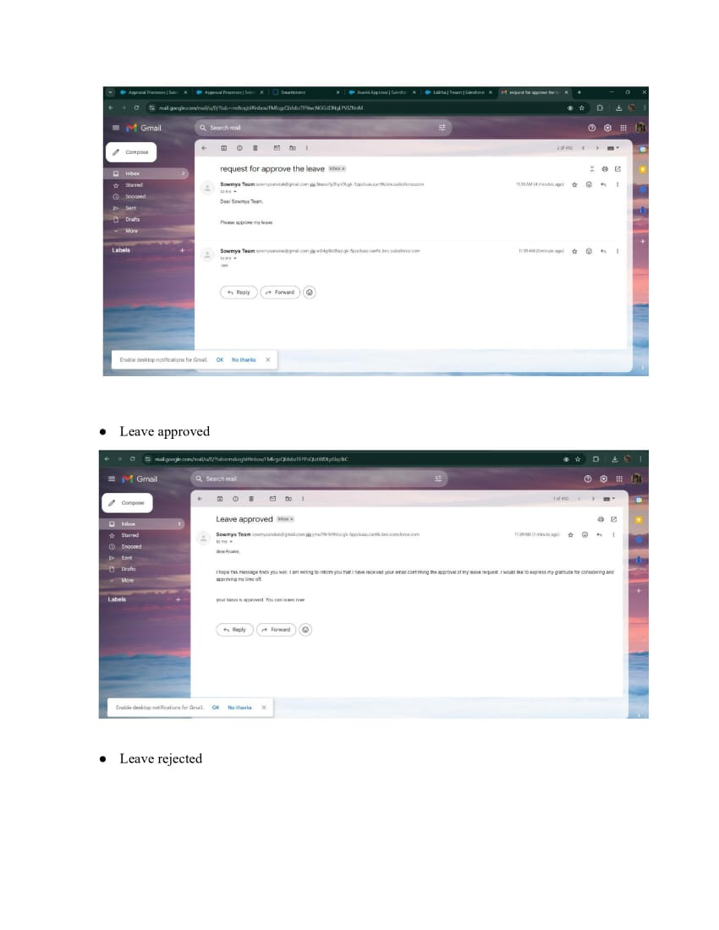

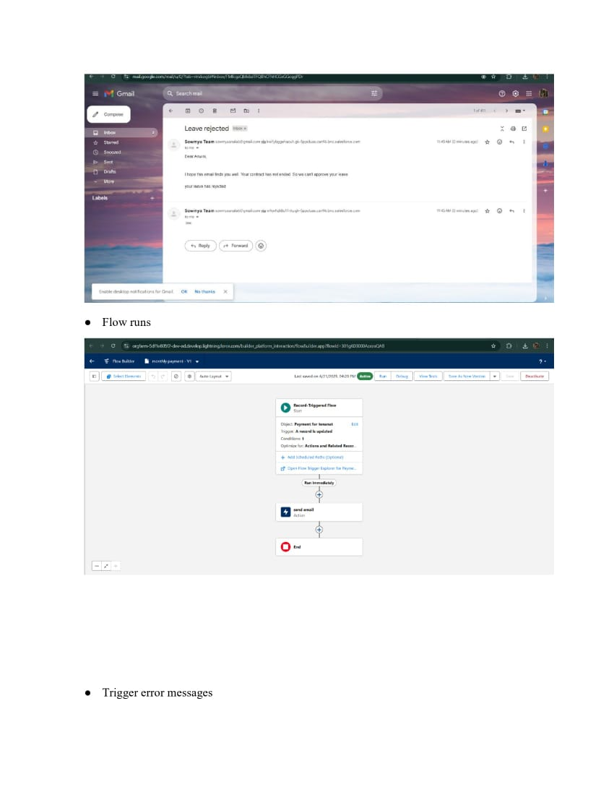

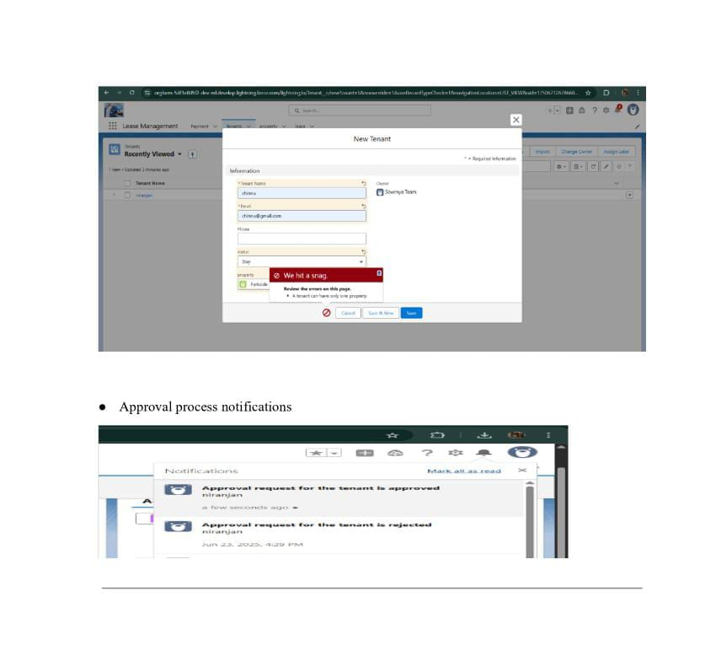

# Conclusion :

# Lease management is an essential process for handling leased assets effectively. It ensures proper tracking of lease agreements, compliance with accounting standards, control, and better decision-making. B y using systematic lease management, organizations can reduce financial risks, improve transparency, and achieve long-term efficiency.

# APPENDIX

# ● Source Code: Provided in Apex Classes and Triggers

# Test.apxt:

# trigger test on Tenant__c (before insert) { if

# (trigger.isInsert && trigger.isBefore){

# testHandler.preventInsert(trigger.new);

# } }

# testHandler.apxc:

# public class

# testHandler {

# public static void

# preventInsert(List<

# Tenant__c> newlist)

# { Set<Id>

# existingPropertyIds

# = new Set<Id>()

# for (Tenant_c existingTenant : [SELECT Id, Propertyc FROM Tenant_c

# WHERE Property__c != null]) {

# existingPropertyIds.add(existingTenant.Property__c;

} for (Tenant__c newTenant :

newlist) {

if (newTenant.Property__c != null &&

existingPropertyIds.contains(newTenant.Property__c)) { newTenant.addError('A

tenant can have only one property');

}

}

}

}

MothlyEmailScheduler.apxc:

global class MonthlyEmailScheduler implements Schedulable {

global void execute(SchedulableContext sc) { Integer

currentDay = Date.today().day(); if (currentDay == 1) {

sendMonthlyEmails();

}

} public static void

sendMonthlyEmails() { List<Tenant__c>

tenants = [SELECT Id, Email__c FROM

Tenant_c]; for (Tenant_c tenant :

tenants) {

String recipientEmail = tenant.Email__c;

String emailContent = 'I trust this email finds you well. I am writing to remind you

that the monthly rent is due Your timely payment ensures the smooth functioning of our

rental arrangement and helps maintain a positive living environment for all.';

String emailSubject = 'Reminder: Monthly Rent Payment Due'; Messaging.SingleEmailMessage email = new

Messaging.SingleEmailMessage(); email.setToAddresses(new

String[]{recipientEmail}); email.setSubject(emailSubject);

email.setPlainTextBody(emailContent);

Messaging.sendEmail(new Messaging,SingleEmailMessage[]{email});

}

}

}